**The Food Order**

* **The Food Order:**

**This document contains sections for:**

* Project Description
* Core concepts used in project
* Flow of the Application.
* Project Users Stories : ( Agile and Scrum )
* Git Repositories
* How to run project
* Demonstrating the product capabilities, appearance, and user interactions.
* Unique Selling Points of the Application
* Conclusions

The project is developed by DEVI J S

* **Project Description:**

DESCRIPTION

Project objective:

Food Order is an e-commerce portal that lets people shop  basic food items on their website. The website needs to have the following features:

* A search form in the home page to allow entry of the food items to be purchased by the customer.
* Based on item details entered, it will show available food items with  price.
* Once a person selects an item to purchase, they will be redirected to the list of available items. In the next page, they are shown the complete breakout of the order and details of the payment to be made in the payment gateway

For the above features to work, there will be an admin backend with the following features:

* Admin login page where admin can change password after login if he wants to
* A master list of food items available for purchase
* A functionality to add or remove food items

* **Core concepts used in the project:**

-> VS Code

-> TypeScript

-> HTML

-> CSS

-> BootStrap

->java

->Mysql

TECHNOLOGIES AND TOOLS USED:

Spring MVC: to build web applications as it follows the Model-View-Controller design pattern.

• Angular for FronteEnd with visual studio code.

• BackEnd with SpringToolSuite(STS).

• Mysql for database.

**Architecture diagram / flow chart**

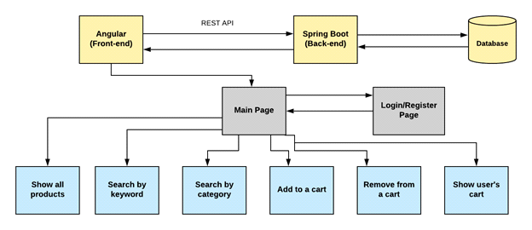

* **Project Users Stories : ( Agile and Scrum )**

The project is planned to be completed in 3 sprints. Tasks assumed to be completed in the sprint are:

* Creating the flow of the application
* Initializing git repository to track changes as development progresses.
* Writing the Java program to fulfill the requirements of the project.
* Testing the Java program with different kinds of User input
* Pushing code to GitHub.

1) As an admin I can Set up a product list of all the shoes.

2) As an admin I can Delete any shoe product.

3) As an admin I can Manage users.

4) As an admin I can change new password.

5)As a User, I can add product to the list.

The goal of the company is to deliver a high-end quality product as early as possible.

Sprint 1

* Show all products to the home page.
* On home page you can Select Item for Buy..
* Enable the ability to search for a specific product
* User can input As Admin & User.
* Home button That return you back on home page.
* Card button for user and card input detail with add product for add..

Sprint 2

* Click on Buy button you get Input page for resgister as user.
* After sumit detail you can add button in that

Sprint 3

* Angular for full Frontend acess .
* Springboot for .BackEnd .
* Mysql for dataabse
* After this put all code on github

The goal of the company is to deliver a high-end quality product as early as possible.

**Demonstrating the product capabilities, appearance, and user interactions**

To demonstrate the product capabilities, below are the sub-sections configured to highlight appearance and user interactions for the project:

All above mentioned file are attached via zip file all these are

**Outputs:**

Home Page For Order

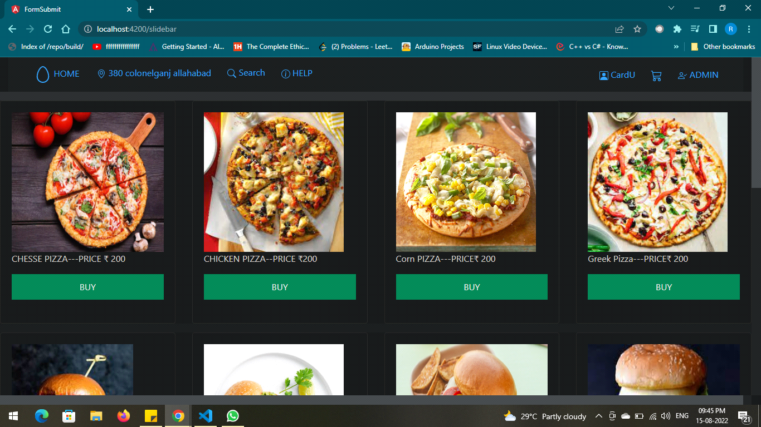

Order Item

-------------

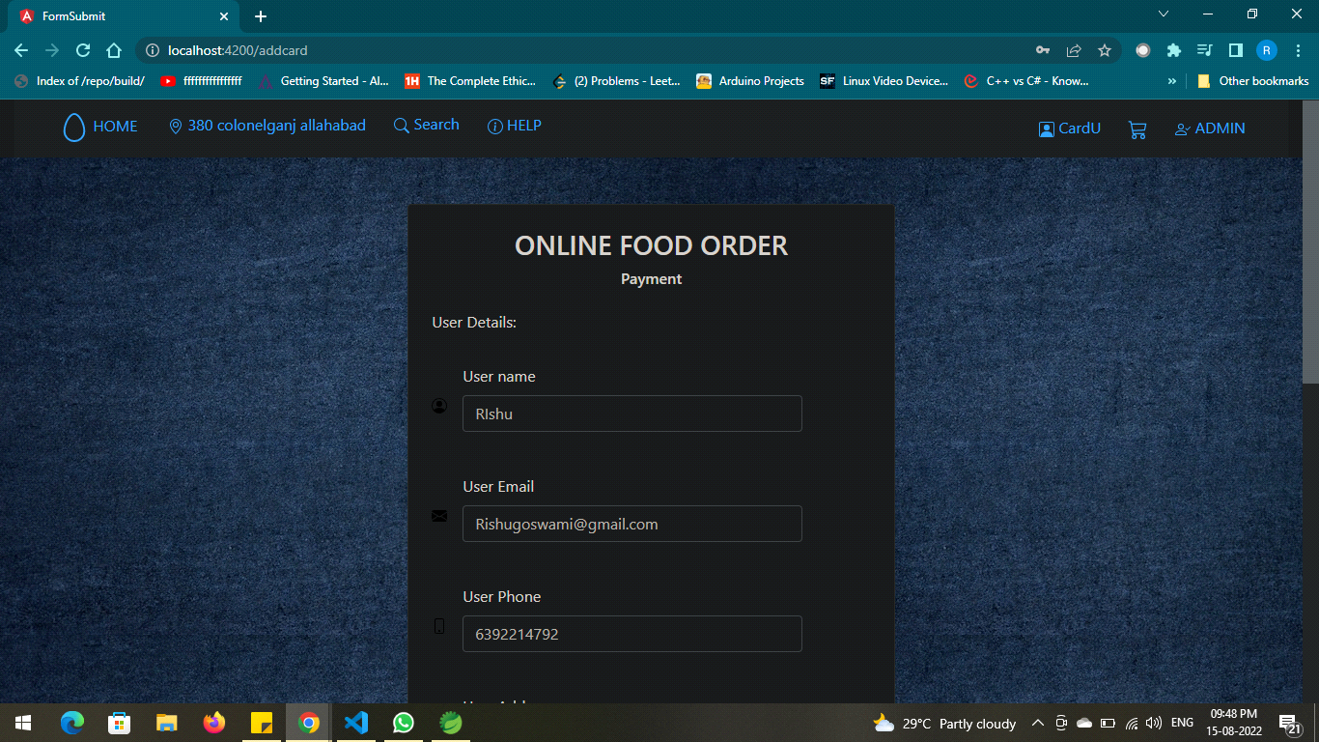

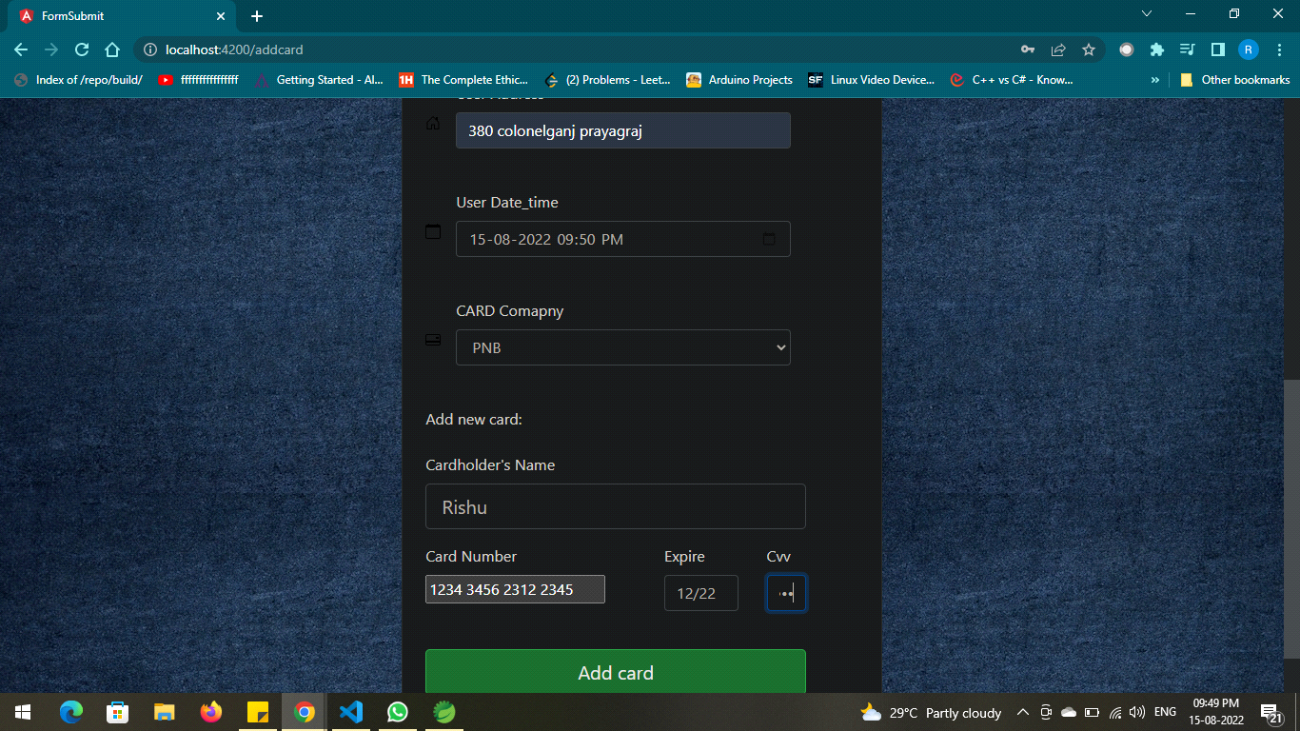--------------------

Search Item

------------------

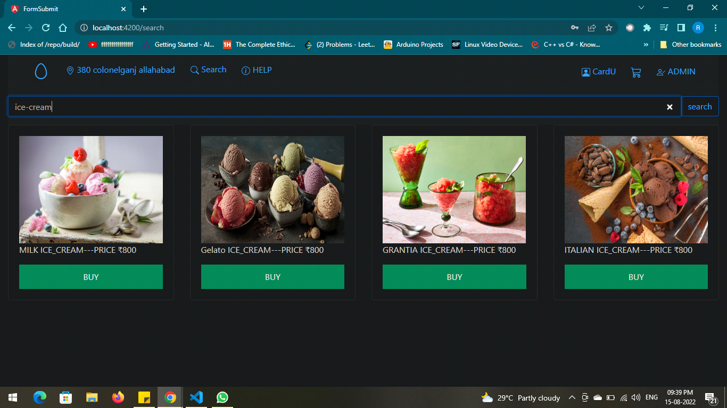

-------

---------------------------------

ss**Step 4:** Pushing the code to GitHub repository

* Open your command prompt and navigate to the folder where you have created your files.

*cd <folder path>*

* Initialize repository using the following command:

*git init*

* Add all the files to your git repository using the following command:

*git add .*

* Commit the changes using the following command:

*git commit . -m <commit message>*

* Push the files to the folder you initially created using the following command:

*git push -u origin master*

**Unique Selling Points of the Application**

* Send food_order for users can be maintained easily.
* The data of the users and Food can be edited easily.
* High security for the data as the admin only can access the data.
* Searching for any data about users is made easy

**Conclusions**

In the program an application has been developed with a duration of three spirits. This application makes handling the data of the Online Food order. All the data about the Food order, user’s purchase details and their schedule are maintained. The admin can login through a User ID and password and manipulated the data.